Parth Babbar

CREDIT SCORING MODELS

Introduction:
Credit scoring models are complex algorithms used by banks and financial organizations in the United States to determine the creditworthiness of applicants for loans, mortgages, credit cards, and other financial goods. These models use multiple characteristics from an individual's credit history to anticipate payback and successfully manage loan risks.
Key Features:
- Predictive Power: Credit scoring methods employ prior credit data to forecast future credit behaviour, allowing lenders to properly assess risk.
- Standardization: Credit scoring models such as FICO and Vantage Score give standardized credit ratings, allowing for easier comparisons across lenders and goods.
- Automation: Automated scoring techniques allow for rapid and uniform credit determinations, which streamlines the lending process for both lenders and borrowers.
- Continuous Improvement: As data analytics advances, scoring models develop, including new data sources and improving algorithms to improve predicted accuracy.
Types:
- FICO Score: The Fair Isaac Corporation established the FICO score, which is now the most extensively used credit scoring model in the US. Scores vary from 300 to 850 and are determined by characteristics such as payment history, credit use, duration of credit history, credit mix, and current credit conduction scores are used by many lenders to determine credit judgments due to its long-standing legitimacy and general acceptance.
- Vantage Score: Developed by Equifax, Experian, and TransUnion, it offers an alternative to FICO scores. Scores range from 300 to 850 and apply similar criteria to FICO, however specific elements may be weighed differently. Lenders are increasingly using this scoring model as a complement or alternative to FICO.
- Customized Credit Scoring Models: Some lenders create proprietary scoring models based on their lending criteria and consumer demographics. These models allow lenders to tailor credit evaluations to their own risk management strategies and commercial objectives.
Components:
Credit rating models often consider the following main factors:
- Payment History: Comparison of on-time payments against late payments or defaults.
- Credit Utilization: The percentage of current credit balances to credit limits for all accounts.
- Length of Credit History: How long have accounts been open and active.
- Credit mix: A variety of credit accounts, including credit cards, instalment loans, and mortgages.
- New Credit: Recent credit applications and freshly created accounts.
Benefits:
- Improved Credit Access: Models enable lenders to efficiently assess credit risk, allowing more people to obtain loans based on their financial behaviour.
- Risk Management: Effective risk assessment enables lenders to reduce financial losses by identifying high-risk borrowers and altering loan conditions accordingly.
- Competitive Interest Rates: Borrowers with stronger credit scores can qualify for cheaper interest rates, saving money over the course of the loan.
- Standardized Evaluation: Standardized scoring methodologies ensure consistency and openness in credit evaluations, encouraging fair lending practices.
Challenges:
- Data Accuracy and Completeness: Credit bureaus' inaccurate or incomplete credit information might have an influence on credit score dependability.
- Bias in Scoring: Scoring algorithms may unintentionally reflect biases against specific demographic groups or persons with low credit histories.
- Scoring Model Complexity: Consumers may struggle to grasp how credit scores are created and perceived.
Solutions:
- Enhanced Data Quality:
1.Strategy: Work with credit bureaus and data suppliers to improve the quality and comprehensiveness of credit information.
2.Impact: Reliable data improves the prediction capacity of scoring algorithms and lowers the likelihood of incorrect credit judgments.
- Fairness and transparency:
1.Strategy: Conduct regular reviews and validations of scoring algorithms to identify and reduce any biases.
2.Impact: Encourages fair lending practices and fosters customer trust in the credit evaluation process.
- Consumer Education:
1.Strategy: Offer customers information to help them understand credit scoring, read credit reports, and enhance their creditworthiness.
2.Impact: Enables people to make more educated financial decisions and actively manage their credit profiles.
Future Trend:
- Incorporation of Alternative Data:
1.Trend: Consider using non-traditional data sources (such as rental payments and utility bills) to enhance traditional credit data.
2.Advantage: Offers a more complete picture of a person's creditworthiness, particularly for individuals with low credit history.
- AI and Machine Learning:
1.Trend: Use AI and machine learning techniques to improve the predicted accuracy and efficiency of credit scoring models.
2. Advantage: Allows for real-time decision-making, individualized credit offers, and proactive risk management.
Statistics:
- Average Credit Score: According to the most recent data, the average FICO score in the United States is roughly 711.
- Credit Score Distribution: Approximately 59% of Americans have a FICO score higher than 700, signifying strong to exceptional creditworthiness.
- High Credit Scores: Nearly 21% of Americans have a FICO score of 800 or above, signifying good credit.
- Low Credit Scores: Approximately 15% of Americans have a FICO score below 600, which is classified as bad credit.
- Age and Credit Score:
18-29 Age Group: Average FICO score is 660.
30-39 Age Group: Average FICO score is 677.
40-49 Age Group: Average FICO score is 690.
50-59 Age Group: Average FICO score is 709.
60+ Age Group: Average FICO score is 743.
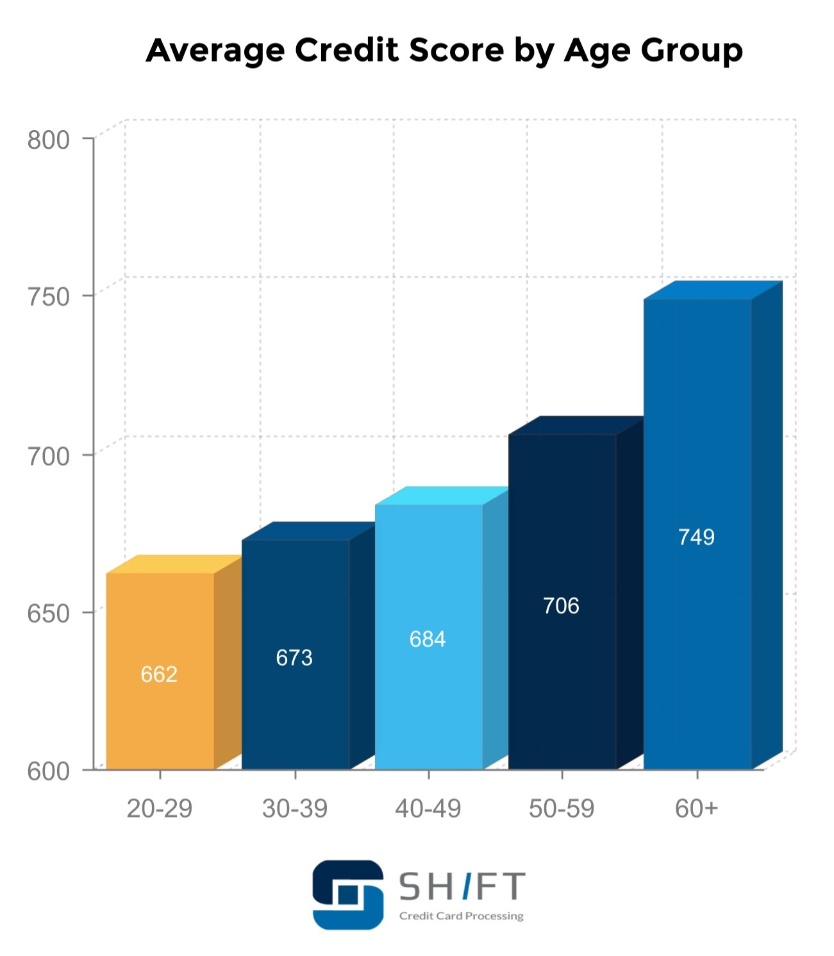
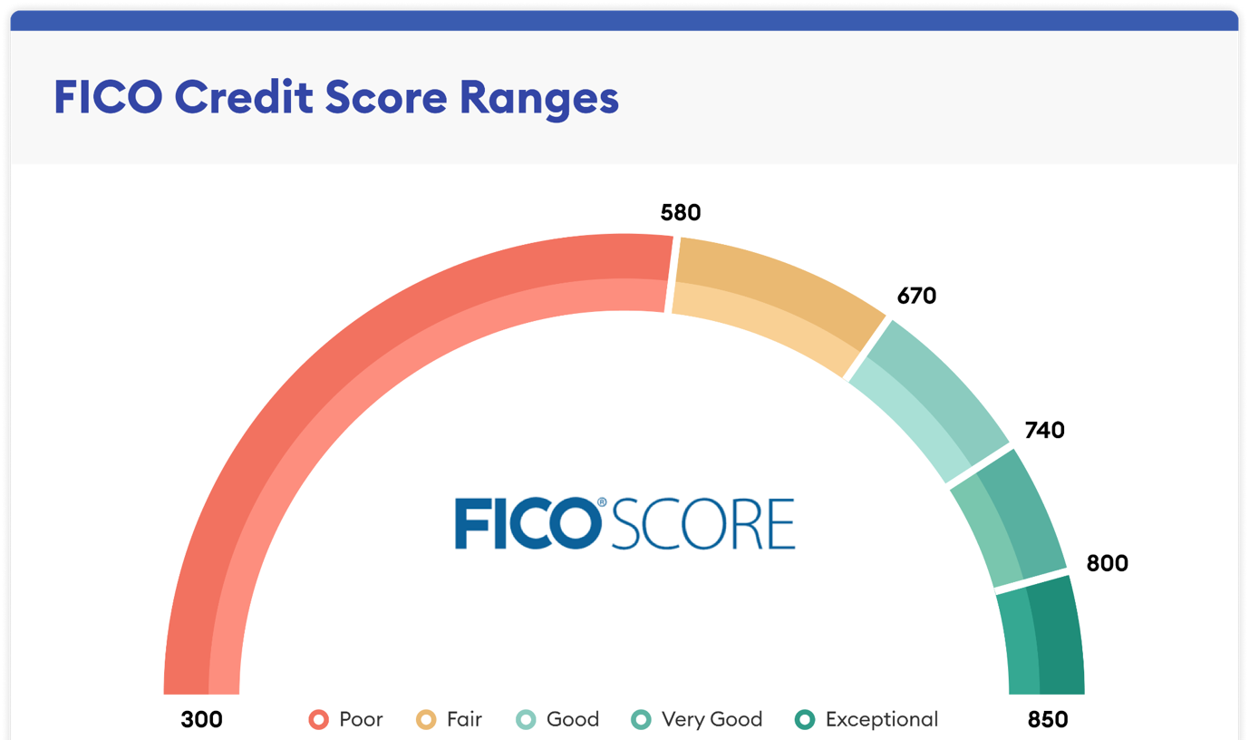
Conclusion:
Credit scoring models are critical tools in US banking, allowing lenders to measure risk and make educated lending decisions. While these models give useful insights, continued attempts to address issues such as data quality, bias, and complexity are essential for ensuring fairness and transparency in the credit rating process. By implementing new technology and increasing consumer education, the banking industry may enhance credit scoring methods and promote financial inclusion for all.

